Project Presentation Script

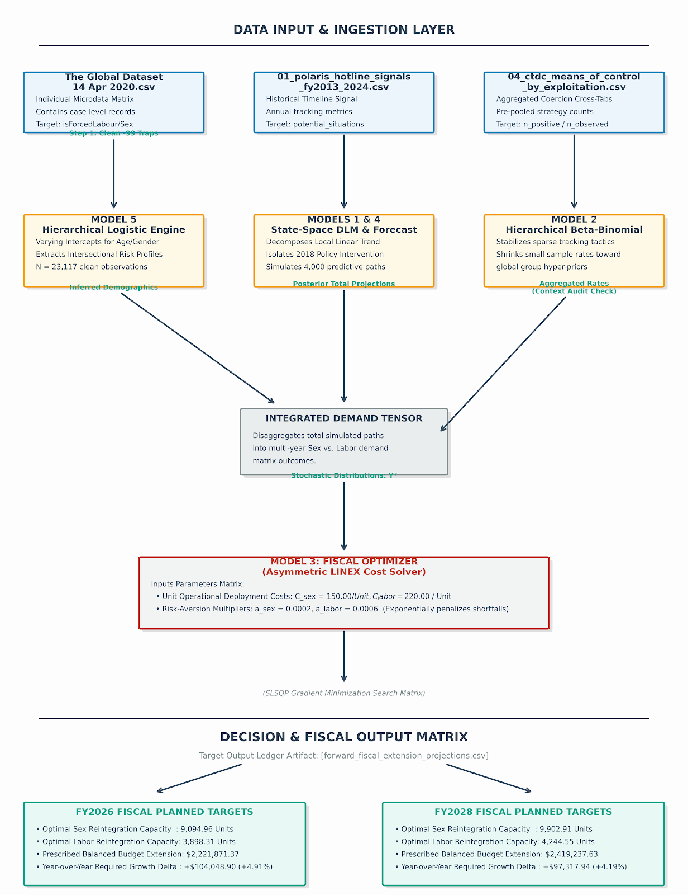
Imagine you are the director of a network of emergency shelters and support services. Every day, your mission is to make sure that when a victim of human trafficking reaches out for help, a safe bed, a counselor, and a legal aid advocate are waiting for them.
But you face three massive hurdles: human trafficking is a hidden crime, your funding is strictly limited, and your data is messy.
To solve this, your team built a smart digital assistant. Here is the story of how that assistant works, broken down step by step, without a single line of code.

Step 1: Sorting through the Fog (The Master Data Cleaner)
The assistant begins by opening a massive, global ledger containing thousands of historical records of survivors. But this ledger has a major flaw: whenever a case is sensitive, or a detail is unknown, the person filling out the paperwork typed in a dummy code: -99.
If a basic computer program read this, it would think there were millions of victims aged "negative 99" experiencing "negative 99" types of harm. It would cause total chaos.
Your digital assistant’s first job is like a meticulous archivist. It carefully goes through the ledger, finds every single rows containing those confusing -99 trap doors, and gently sweeps them away. This leaves you with a crystal-clean, verified pool of actual human stories to learn from.

Step 2: Reading the Demographic Signs (The Profile Reader)
Now that the ledger is clean, the assistant looks for patterns. It notices that trafficking isn't uniform.
By analyzing the age and gender of tens of thousands of individuals, it uncovers a vital human insight: vulnerability changes as we grow up.
- When it looks at the records of young teenagers, it notices they are heavily targeted for sexual exploitation.
- But as it looks at older age brackets, the risk completely flips. For adults in their 30s, 40s, and beyond, the data reveals a striking 80%+ probability that they are trapped in labor exploitation (like forced factory work or agricultural abuse).
The assistant remembers these percentages. They tell us exactly what kind of help different age groups will likely need.

Step 3: Looking into the Future (The Time-Traveler)
Next, the assistant leaves the individual records behind and looks at a timeline of total calls made to the Polaris national trafficking hotline over the last decade.
It maps the history: how calls rose, how they shifted when a major anti-trafficking law passed in 2018, and where they stand today. Then, it does something incredible: it pretends to travel into the future.
Because we can't know the future perfectly, the assistant doesn't just guess one single number for next year. Instead, it simulates 4,000 different future pathways at the same time. It lets random events bump the lines up and down, creating a realistic map of possibilities.
When it finishes, it gives you a clear warning: Latent demand is rising. We expect about 12,384 cases next year, and if current trends hold, that number will climb to over 14,148 cases in a few years.

Step 4: The Heart of the Model (The Asymmetric Optimizer)
This is where everything comes together, and where the model acts less like a calculator and more like a human policymaker.
The assistant takes the future case predictions and uses the demographic percentages to calculate exactly how many safe beds you will need for sex trafficking survivors versus labor trafficking survivors.
Now, you have to decide how to spend your budget. A normal computer program would just look at the average number of expected cases and fund exactly that many beds. But you tell the assistant: "A mistake in our world isn't just a math error. It's a tragedy."
You explain the asymmetric rules of your job:
- If we build a bed that sits empty (A False Positive): We waste a little bit of money. That's unfortunate, but the shelter stays open.
- If a real victim calls and we have no bed left (A False Negative): A human being is turned away and sent back into harm's way. This is a catastrophic failure.
Furthermore, you tell the assistant that labor trafficking victims are historically much harder to find, meaning an empty bed there is a much bigger risk to leave unaddressed.
The assistant nods, takes your real-world costs ($150 for a sex-trafficking service slot, $220 for a labor slot), and runs a specialized calculation. It intentionally over-orders capacity. It builds a safety cushion because it knows that being safe is infinitely better than being sorry.

The Final Deliverable
At the end of the day, the assistant hands you a neat, one-page business plan. It doesn't tell you to wait around until the crisis happens. Instead, it looks you in the eye and gives you a proactive blueprint:
"To protect everyone next year without leaving a single soul out in the cold, you shouldn't just guess your budget. You need to authorize exactly $2,117,822.46 right now. Allocate enough funds for 8,669 sex reintegration units, and 3,715 labor units. And because the threat is growing, be ready to increase your funding by about 4.9% next year to keep your safety net strong."
By turning messy historical data into a forward-looking shield, this model ensures that your organization is no longer just reacting to the tragedy of human trafficking—you are actively outsmarting it.

